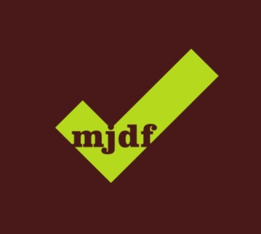

**Royal College of Surgeons of England (RCSEng)**

**MJDF PART 1 EXAMINATION Information**

**Candidate Application Process**

* Candidate can apply online only through the RCSEng website at: <http://www.rcseng.ac.uk/exams/apply-online>
* More information for the candidates on the application process can be found at: <http://www.mjdf.org.uk/apply-online/guidance-on-the-mjdf-portfolio-of-evidence>
* Candidates whose names do not appear in the current UK dentists register (General Dental Council) must submit evidence (in the form of original documentation or certified copies*) of the following:
  + Primary dental qualification, together with the date of acquisition. The qualification a candidate hold need to be referred on the following website: <http://avicenna.ku.dk/database/medicine/>
  + Registration document

*Copies of letters and certificates will only be accepted if they have been verified as a true copy. Attested copies must bear an original signature and official stamp (e.g. hospital stamp, public notary stamp). Official English translations from a translation agency will be required for stamps or certificates that are not in English. For the above, we are happy to accept the copies which have been attested by the British Council.

* Candidates will received an admission letter 2-4 weeks before the date of the exam notifying them of the time of the exam, venue and their candidate number.

**Exam Fees**

* The exam fee if currently **£522**.
* The British Council centre needs to let the RCSEng know its local administration fee per candidate. This fee will be attached to the exam fee which candidates pay at the time of their online application. Therefore, RCSEng will collect both fees at the same time. For comparison, the British Council Cairo fee is £40.
* After the application deadline has passed the British Council centre will invoice the RCSEng for the total amount of the local administration fee which the RCSEng will pay.

**Timeline**

* Applications open – as soon as possible
* Application deadline – 31 August
* Admission letters send to candidates by – 21 September
* MJDF Part 1 exam – 5 October
* Release of results – 9 November
* Result letters posted by – 23 November

**Exam Day**

* This is a three hour exam
* The exam must take place at the exact same time in all the centres. The benchmark time is London, UK time 10:00-13:00
* The exam needs to be overseen by a Lead Invigilator and at least one other Invigilator per 30 candidates
* Exam materials needed are as follows:

The following items are provided by the centres:

|  |  |
| --- | --- |
| Pencils | 1 per candidate plus spares |
| Erasers | 1 per candidate plus spares |
| Desk numbers | Candidate numbers will be sent in advance to allow time for printing |

The following items are provided by RCSEng:

|  |  |
| --- | --- |
| Question papers | 1 per candidate plus spares |
| Answer papers | 1 per candidate plus spares |
| Feedback forms | 1 per candidate plus spares |
| List of candidates / registration list / absentee list |  |
| Briefing instructions |  |
| Instructions for invigilators |  |
| Admission Forms | For candidates who do not bring an admission letter |